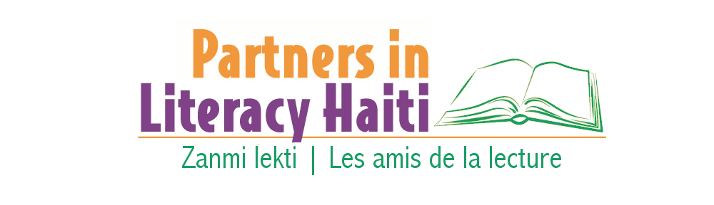
Bibliothèque Communautaire de Cange | Cange Public Library Nurturing and developing partnerships that help Haitian children grow and sustain literacy.

Links to Videos about the Cange Community Library, Haiti

Haitian and American voices and faces give visibility to our efforts with the Cange Community Library Project, as we work to develop the only public library in the Central Plateau.

Having successfully grown in the last 3 years, the Cange Library is seeking funds to expand and to build a new library to accommodate rapid patron growth. Each video is less than five minutes in length.

1. Come with us to Cange, Haiti. Photo slideshow: A visual journey to Cange , to the village, and to the library; slides are accompanied by muted choir music from the Cange Episcopal Church.
https://vimeo.com/141214148

2. Introduction: Dr. Sara Mansbach, project advisor, provides an overview of the project.
https://vimeo.com/141216132

3. Leaders: 3 Haitians leaders--a minister in the Central Plateau, a program administrator, and a minister from Cange talk about why the village needs a library.
https://vimeo.com/141319772

4. Young Adults: An Episcopal internship student and a Cange high school senior assess the need.
https://vimeo.com/141317906

5. Volunteers: Rotarian Dianne Clarke-Kudless talks about how Rotarians and other volunteers can become involved and contribute to the project.
https://vimeo.com/141318582

6. A Library for Cange, Haiti. Photo slideshow that consists only of photos of Cange village, rural schools, culture, and community surroundings except for 3 informational slides at the end. There is no background music. There are 40 slides.

Videos were produced with a First Baptist Church of Greenville, SC’s Missions Committee grant and support from Rotary District 7750 in March 2015. Bootie Cothran producer.
Created by Elaina Griffith, MILS, Furman University librarian for presentation at the South Carolina Library Association 100th Anniversary Convention.

